**Stimuli für Erkennung der Emotion (40 Items):**

|  |  |  |  |  |  |  |  |  |  |  |  |  |  |  |  |  |  |  |  |  |  |  |  |  |  |  |  |  |  |  |  |  |  |  |  |  |  |  |  |  |  |  |  |  |  |  |  |  |  |  |  |  |  |  |  |  |  |  |  |  |  |  |  |  |  |  |  |  |  |  |  |  |  |  |  |  |  |  |  |  |  |  |  |  |  |  |  |  |  |  |  |  |  |  |  |  |  |  |  |  |  |  |  |  |  |  |  |  |  |  |  |  |  |  |  |  |  |  |  |  |  |  |  |  |  |  |  |  |  |  |  |  |  |  |  |  |  |  |  |  |  |  |  |  |  |  |  |  |  |  |  |  |  |  |  |  |  |  |  |  |  |  |  |  |  |  |  |
| --- | --- | --- | --- | --- | --- | --- | --- | --- | --- | --- | --- | --- | --- | --- | --- | --- | --- | --- | --- | --- | --- | --- | --- | --- | --- | --- | --- | --- | --- | --- | --- | --- | --- | --- | --- | --- | --- | --- | --- | --- | --- | --- | --- | --- | --- | --- | --- | --- | --- | --- | --- | --- | --- | --- | --- | --- | --- | --- | --- | --- | --- | --- | --- | --- | --- | --- | --- | --- | --- | --- | --- | --- | --- | --- | --- | --- | --- | --- | --- | --- | --- | --- | --- | --- | --- | --- | --- | --- | --- | --- | --- | --- | --- | --- | --- | --- | --- | --- | --- | --- | --- | --- | --- | --- | --- | --- | --- | --- | --- | --- | --- | --- | --- | --- | --- | --- | --- | --- | --- | --- | --- | --- | --- | --- | --- | --- | --- | --- | --- | --- | --- | --- | --- | --- | --- | --- | --- | --- | --- | --- | --- | --- | --- | --- | --- | --- | --- | --- | --- | --- | --- | --- | --- | --- | --- | --- | --- | --- | --- | --- | --- | --- | --- | --- | --- | --- | --- |
| |  |  |  |  | | --- | --- | --- | --- | | N_Kategorie | Item_2 Silben |  | Emo_Valence | | Gemüse | **Weißkohl** |  | 4,09 | | Gemüse | **Grünkohl** |  | 5,186 | | Gemüse | **Knoblauch** |  | 4,377 | | Gemüse | **Kürbis** |  | 5,381 | | Gemüse | **Ingwer** |  | 5,335 | | Gemüse | **Chili** |  | 5,648 | | Gemüse | **Bärlauch** |  | 5,517 | | Obst | **Himbeer** |  | 6,446 | | Obst | **Kiwi** |  | 6,79 | | Obst | **Mango** |  | 6,208 | | Obst | **Pfirsich** |  | 6,554 | | Getränke | **Fruchtsaft** |  | 5,889 | | Getränke | **Eistee** |  | 6,316 | | Getränke | **Cola** |  | 5,543 | | Getränke | **Kaffee** |  | 5,971 | | Getränke | **Cocktail** |  | 6,443 | | Getränke | **Rotwein** |  | 6,784 | | Getränke | **Weißwein** |  | 6,357 | | Getränke | **Joghurt** |  | 5,759 | | Essen | **Honig** |  | 6,18 | | Essen | **Pizza** |  | 6,049 | | Essen | **Toastbrot** |  | 6,032 | | Essen | **Bratwurst** |  | 6,165 | | Essen | **Ketchup** |  | 5,194 | | Essen | **Weißwurst** |  | 5,813 | | Essen | **Sushi** |  | 6,124 | | Essen | **Thunfisch** |  | 5,269 | | Essen | **Gulasch** |  | 5,574 | | Essen | **Erdnuss** |  | 6,171 | | Essen | **Auflauf** |  | 4,628 | | Schulfächer | **Bio** |  | 4,975 | | Schulfächer | **Englisch** |  | 5,533 | | Schulfächer | **Russisch** |  | 4,582 | | Schulfächer | **Wirtschaft** |  | 4,785 | | Schulfächer | **Technik** |  | 5,484 | | Tier | **Panda** |  | 6,343 | | Tier | **Zebra** |  | 5,308 | | Tier | **Käfer** |  | 4,489 | | Tier | **Lama** |  | 6,062 | | Tier | **Tiger** |  | 5,025 | |  |  |  |

**Auswerten von Stimuli Emotion:**

|  |  |  |
| --- | --- | --- |
| **Statistikena** | | |
| Valence | | |
| N | Gültig | 40 |
| Fehlend | 0 |
| Mittelwert | | 5,65948 |
| Median | | 5,70350 |
| Modus | | 4,090b |
| Standardabweichung | | ,683639 |
| Varianz | | ,467 |
| Minimum | | 4,090 |
| Maximum | | 6,790 |
| a. Stimulitypen = Emotion | | |
| b. Mehrere Modi vorhanden. Der kleinste Wert wird angezeigt. | | |

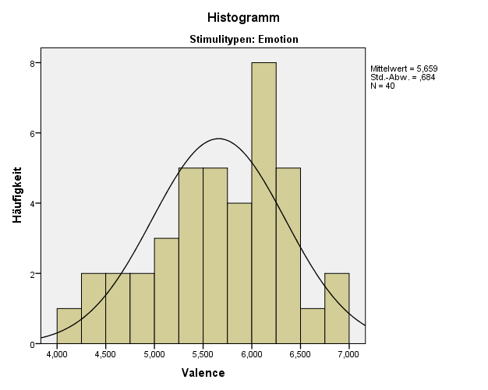

**Stimuli für Erkennung der Satztypen: (34 Items)**

|  |  |  |
| --- | --- | --- |
| N_Kategorie | Item_3 Silben | Valence |
| Gemüse | **Chinakohl** | 4,161 |
| Gemüse | **Blumenkohl** | 4,948 |
| Gemüse | **Champignon** | 4,559 |
| Gemüse | **Feldsalat** | 5,404 |
| Gemüse | **Paprika** | 4,973 |
| Gemüse | **Löwenzahn** | 6,243 |
| Gemüse | **Sellerie** | 4,509 |
| Gemüse | **Estragon** | 4,786 |
| Gemüse | **Majoran** | 4,765 |
| Gemüse | **Thymian** | 5,129 |
| Obst | **Ananas** | 5,957 |
| Getränke | **Früchtetee** | 6,718 |
| Getränke | **Apfelwein** | 5,483 |
| Getränke | **Buttermilch** | 6,077 |
| Getränke | **Milchkaffee** | 6,415 |
| Getränke | **Alkohol** | 4,454 |
| Getränke | **Honigwein** | 5,757 |
| Getränke | **Eiskaffee** | 6,266 |
| Essen | **Bratapfel** | 6,354 |
| Essen | **Haselnuss** | 6,555 |
| Essen | **Obstsalat** | 6,69 |
| Essen | **Kokosnuss** | 6,343 |
| Essen | **Paranuss** | 5,659 |
| Tier | **Stachelschwein** | 4,462 |
| Tier | **Warzenschwein** | 4,432 |
| Tier | **Ameisen** | 4,928 |
| Tier | **Pinguin** | 5,942 |
| Tier | **Eichhörnchen** | 6,655 |
| Tier | **Känguru** | 6,535 |
| Tier | **Schmetterling** | 6,693 |
| Tier | **Kakadu** | 5,228 |
| Tier | **Tintenfisch** | 4,736 |
| Tier | **Meerschweinchen** | 5,423 |
| Tier | **Nasenbär** | 5,742 |

**Auswerten von Stimuli Satztypen:**

|  |  |  |
| --- | --- | --- |
| **Statistikena** | | |
| Valence | | |
| N | Gültig | 34 |
| Fehlend | 0 |
| Mittelwert | | 5,55826 |
| Median | | 5,57100 |
| Modus | | 4,161b |
| Standardabweichung | | ,812251 |
| Varianz | | ,660 |
| Minimum | | 4,161 |
| Maximum | | 6,718 |
| a. Stimulitypen = Satztyp | | |
| b. Mehrere Modi vorhanden. Der kleinste Wert wird angezeigt. | | |

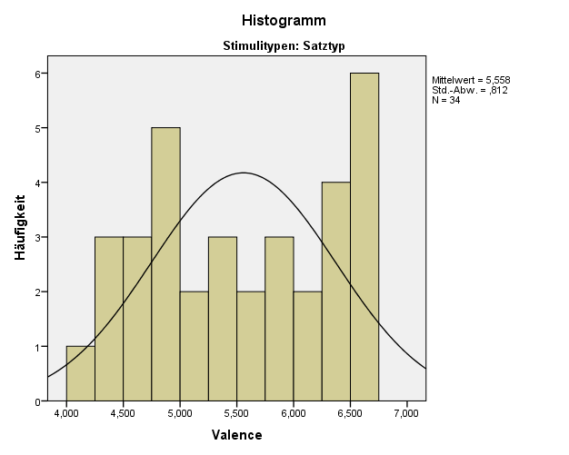

Keinen Wert bei *Affective Norms* von diesen Wörtern gefunden, bzw. zu niedrig:

**Stimuli für den Übungsteil der Erkennung von Emotionen: (8 Items)**

|  |  |
| --- | --- |
| Obst | **Kokos** |
| Obst | **Kaki** |
| Obst | **Lychee** |
| Getränke | **Grüntee** |
| Getränke | **Ouzo** |
| Getränke | **Mocha** |
| Essen | **Muffin** |
| Tier | **Python** |

**Stimuli für den Übungsteil der Erkennung von Satztypen: (10 Items)**

|  |  |  |  |  |  |  |  |  |  |  |  |  |  |  |  |  |  |  |  |  |  |  |  |  |  |  |  |  |  |  |  |
| --- | --- | --- | --- | --- | --- | --- | --- | --- | --- | --- | --- | --- | --- | --- | --- | --- | --- | --- | --- | --- | --- | --- | --- | --- | --- | --- | --- | --- | --- | --- | --- |
| |  |  |  | | --- | --- | --- | | Gemüse | **Brokkoli** |  | | Gemüse | **Rucola** |  | | Gemüse | **Maniok** |  | | Gemüse | **Zuckermais** |  | | Gemüse | **Rossmarie** |  | | Obst | **Speierling** |  | | Obst | **Pomelo** |  | | Essen | **Pekannuss** |  | | Tier | **Igelfisch** |  | | Tier | **Blutegel** | 3,338 | |  |
|  |  |

**Füller Stimuli: (106 Items)**

|  |  |  |  |  |
| --- | --- | --- | --- | --- |
| **N_Kategorie** | **Füller** | **Item_Silben** | **Akzentmuster** |  |
| Gemüse | **Zwiebel** | 2 | Zw`ie-bel | * |
| Gemüse | **Bohne** | 2 | B`oh-ne |  |
| Gemüse | **Möhre** | 2 | M`öh-re |  |
| Gemüse | **Pilze** | 2 | P`il-ze |  |
| Gemüse | **Gurken** | 2 | G`ur-ken |  |
| Gemüse | **Kräuter** | 2 | Kr`äu-ter |  |
| Gemüse | **Spargel** | 2 | Sp`ar-gel |  |
| Gemüse | **Tomate** | 3 | To-m`a-te |  |
| Gemüse | **Zucchini** | 3 | Zuc-ch`i-ni |  |
| Gemüse | **Kartoffel** | 3 | Kar-t`of-fel |  |
| Obst | **Apfel** | 2 | `Ap-fel |  |
| Obst | **Traube** | 2 | Tr`au-be |  |
| Obst | **Birne** | 2 | B`ir-ne |  |
| Obst | **Nüsse** | 2 | N`üs-se |  |
| Obst | **Feige** | 2 | F`ei-ge |  |
| Obst | **Kirsche** | 2 | K`ir-sche |  |
| Obst | **Pflaumen** | 2 | Pfl`au-men |  |
| Obst | **Melone** | 3 | Me-l`o-ne |  |
| Obst | **Banane** | 3 | Ba-n`a-ne |  |
| Obst | **Weintrauben** | 3 | Wein-tr`au-ben |  |
| Obst | **Oliven** | 3 | O-l`i-ven |  |
| Obst | **Erdbeere** | 3 | `Erd-bee-re |  |
| Obst | **Orange** | 3 | O-r`an-ge |  |
| Obst | **Papaya** | 3 | Pa-p`a-ya |  |
| Obst | **Avocado** | 4 | A-vo-c`a-do |  |
| Obst | **Heidelbeere** | 4 | H`ei-del-bee-re |  |
| Obst | **Mandarine** | 4 | Man-da-r`i-ne |  |
| Getränke | **Wasser** | 2 | W`as-ser |  |
| Getränke | **Sake** | 2 | S`a-ke |  |
| Getränke | **Mate** | 2 | M`a-te |  |
| Getränke | **Radler** | 2 | R`ad-ler |  |
| Getränke | **Whisky** | 2 | Wh`is-ky |  |
| Getränke | **Kakao** | 2 | Ka-k`ao |  |
| Getränke | **Holunder** | 3 | Ho-l`un-der |  |
| Getränke | **Espresso** | 3 | Es-pr`es-so |  |
| Getränke | **Limonade** | 4 | Li-mo-n`a-de |  |
| Getränke | **Cappuccino** | 4 | Cap-puc-c`i-no |  |
| Essen | **Nudeln** | 2 | N`u-deln | * |
| Essen | **Schnitzel** | 2 | Schn`it-zel | * |
| Essen | **Brötchen** | 2 | Br`öt-chen | * |
| Essen | **Döner** | 2 | D`ö-ner |  |
| Essen | **Brezel** | 2 | Br`e-zel | * |
| Essen | **Torte** | 2 | T`or-te |  |
| Essen | **Krabbe** | 2 | Kr`ab-be |  |
| Essen | **Kekse** | 2 | K`ek-se |  |
| Essen | **Schoko** | 2 | Scho-k`o |  |
| Essen | **Butter** | 2 | B`ut-ter | * |
| Essen | **Waffel** | 2 | W`af-fel | * |
| Essen | **Schinken** | 2 | Sch`in-ken |  |
| Essen | **Käse** | 2 | K`ä-se |  |
| Essen | **Kuchen** | 2 | K`u-chen |  |
| Essen | **Sahne** | 2 | S`ah-ne |  |
| Essen | **Suppe** | 2 | S`up-pe |  |
| Essen | **Eier** | 2 | `Ei-er |  |
| Essen | **Pommes** | 2 | P`om-mes | * |
| Essen | **Garnieren** | 2 | Gar-n`ier |  |
| Essen | **Mandeln** | 2 | M`an-deln |  |
| Essen | **Salami** | 3 | Sa-l`a-mi |  |
| Essen | **Spaghetti** | 3 | Spa-gh`et-ti |  |
| Essen | **Hamburger** | 3 | H`am-bur-ger | * |
| Essen | **Lasagne** | 3 | La-s`ag-ne |  |
| Essen | **Glasnudel** | 3 | Gl`as-nu-del | * |
| Essen | **Schweinshaxe** | 3 | Schw`eins-ha-xe |  |
| Essen | **Leberwurst** | 3 | L`e-ber-wurst |  |
| Essen | **Frikadellen** | 4 | Fri-ka-d`el-len |  |
| Essen | **Olivenöl** | 4 | O-l`i-ven-öl |  |
| Essen | **Putenschnitzel** | 4 | P`u-ten-schni-tzel |  |
| Essen | **Peperoni** | 4 | Pe-pe-r`o-ni |  |
| Essen | **Mayonnaise** | 4 | Ma-yon-n`ai-se |  |
| Essen | **Mozzarella** | 4 | Moz-za-r`el-la |  |
| Schulfächer | **Chemie** | 2 | Che-m`ie |  |
| Schulfächer | **Latein** | 2 | La-t`ein |  |
| Schulfächer | **Sprache** | 2 | Spr`a-che |  |
| Schulfächer | **Mathe** | 2 | M`a-the |  |
| Schulfächer | **Musik** | 2 | Mu-s`ik |  |
| Schulfächer | **Physik** | 2 | Phy-s`ik |  |
| Schulfächer | **Erdkunde** | 3 | `Erd-kun-de |  |
| Schulfächer | **Französisch** | 3 | Fran-z`ö-sisch |  |
| Schulfächer | **Geschichte** | 3 | Ge-sch`ich-te |  |
| Schulfächer | **Politik** | 3 | Po-li-t`ik |  |
| Schulfächer | **Biologie** | 4 | Bi-o-lo-g`ie |  |
| Schulfächer | **Informatik** | 4 | In-for-m`a-tik |  |
| Schulfächer | **Psychologie** | 4 | Psy-cho-lo-g`ie |  |
| Schulfächer | **Pädagogik** | 4 | Pä-da-g`o-gik |  |
| Schulfächer | **Philosophie** | 4 | Phi-lo-so-ph`ie |  |
| Tier | **Affe** | 2 | `Af-fe |  |
| Tier | **Biene** | 2 | B`ie-ne |  |
| Tier | **Katze** | 2 | K`at-ze |  |
| Tier | **Kamel** | 2 | Ka-m`el |  |
| Tier | **Delfin** | 2 | Del-f`in |  |
| Tier | **Löwe** | 2 | L`ö-we |  |
| Tier | **Schlange** | 2 | Schl`an-ge |  |
| Tier | **Ente** | 2 | `En-te |  |
| Tier | **Spinne** | 2 | Sp`in-ne |  |
| Tier | **Elefant** | 3 | E-le-f`ant |  |
| Tier | **Alpaka** | 3 | Al-p`a-ka |  |
| Tier | **Giraffe** | 3 | Gi-r`af-fe |  |
| Tier | **Krokodil** | 3 | Kro-ko-d`il |  |
| Tier | **Eidechse** | 3 | `Ei-dech-se |  |
| Tier | **Schildkröte** | 3 | Sch`ild-krö-te |  |
| Tier | **Papagei** | 3 | Pa-pa-g`ei |  |
| Tier | **Flamingo** | 3 | Flam-m`in-go |  |
| Tier | **Gazellen** | 3 | Ga-z`el-len |  |
| Tier | **Gorilla** | 3 | Go-r`il-la |  |
| Tier | **Leopard** | 3 | Le-o-p`ard |  |
| Tier | **Koala** | 3 | Ko-`a-la |  |